ANNUAL REPORT
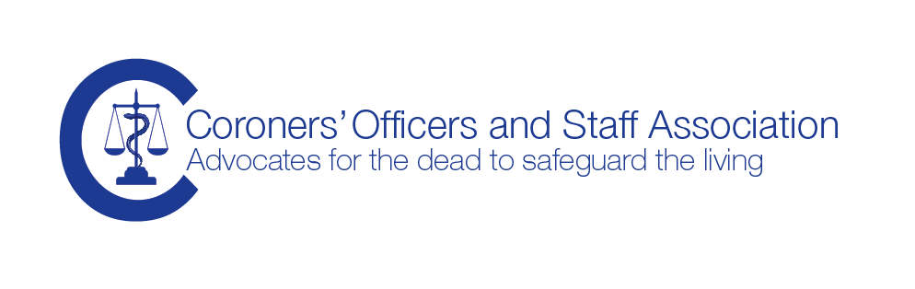

AGM

9th October 2014

Dear Members

It has been another busy year following our last AGM.
The Council of the Association
We have said farewell to Faye, Lindon and Wayne and I would like to record my thanks for all of their valuable contributions, particularly Faye as our website administrator and newsletter editor.
Tony joined the council in 2012 and I am very pleased to welcome him as the recently elected Vice Chair, I am looking forward to working with Tony and take forward many of our projects, most importantly creating a social media presence so that we can be more responsive and interactive in keeping in touch with you all. We are also looking at our website again as there are some technical limitations with our website that make staying in touch cumbersome.
Sonia has been re-elected as the secretary and I am grateful for Sonia’s hard work organising us and keeping the Association in good order.
Christine, Viv and Adam remain on our council and Peter and Geoff remain co-opted. I would like to thank Geoff for his work in keeping our website running since Faye started her maternity leave and I am looking forward to working with the team over the coming year, we have a very strong team working hard to achieve the Aims of the Association on your behalf.
If you are interested in working with the council, either as an elected or co-opted member or if you have a particular interest, skill or experience you would like to share, then please do get in touch with a council member or contact us at secretary@coasa.org.uk
Membership
Our membership continues to grow steadily and we encourage you to solicit new members from amongst your colleagues, coroners’ officers and coroners’ staff. We do have significant interest in our Association from persons that work alongside the coroner service and have an increasing number of affiliate members. If you have colleagues in your office that are not members, then please do let us know. Send us their name, work e-mail and postal address so that we can add them to our mailing list. Send the information to membership@coasa.org.uk
Training
As you know, COASA have always provided a range of excellent training events, either as stand alone study days or working in partnership with a university. The Association is extremely fortunate to have a training group with extensive experience working in the coroner service combined with many years experience as educators and trainers. COASA has argued strongly that training for coroners’ officers and staff should be mandatory and we are very pleased that the chief coroner has stated the same. COASA is working with the chief coroner and Judicial College. In the meantime the chief coroner has indicated that coroners’ officers will be included in the training provided by the Judicial College, a big step forward and we will let you know what is planned as soon as possible.

The Grief and Bereavement Study Day
COASA commissioned a study day in July, which was held in the North West. It was very successful and we plan to repeat the day in 2015, probably more centrally, so do look out for information
Department of Health – death certification reform
The expected consultation on the introduction of the Medical Examiner system has been further delayed, although we believe that it is still intended to take it forward. As yet there is no date for implementation. We will of course update you as soon as we have news.

Coroner Court Support Service Executive Committee

Sonia represents the Association on the national committee

The stakeholder groups:

ACPO coroners’ officer working party and

Coroner Service Stakeholder Group

The work on these groups was progressing well, but both groups seem to have stalled, which is highly disappointing. We will keep you updated as and when the work re-starts.
Sponsorship from Rowland Brothers International
A very kind donation was made to COASA by Rowland Bros. We are very grateful for their financial support, as you know we are funded solely by your subscriptions, which has remained the same for very many years and it means that we have been able to put our otherwise limited funds to good use for some of the projects that might otherwise have taken a bit longer to progress, particularly improving our website, I hope that you will see the benefit early in 2015

A Note from the Chair

I would like to offer my sincere thanks to each of you, the membership, for your continued support. I know that many of you are under severe pressure, the past few months in particular has seen many changes in the workplace for all of us, and the general feeling is that the workload has increased at a time when staffing levels may be falling or frozen.

Much of the work of the Association is not ‘visible’, but please be reassured that we continue to speak on your behalf at every opportunity. I will of course continue to work hard on your behalf along with my council colleagues.

If you would like to contact me, I am always glad to hear from members, whether it is information you want to share, or something you think I may be able to assist you with, please do get in touch.

Thank-you for your valuable support.

Debbie Large

Chair, Coroners’ Officers and Staff Association

8th October 2014

01634 799182 | chair@coasa.org.uk | 115 Charles Drive, Cuxton, Rochester, ME2 1DU
COASA general correspondence to: secretary@coasa.org.uk | PO Box 3781, Chester, CH1 9YJ

