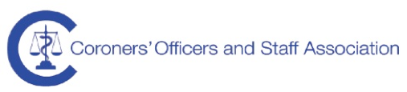
Dear Colleagues

Coroners Officers and Staff Managers Workshop

The Coroners Officers and Staff Association (COASA) who would like to extend an invitation to all Coroner’s Officer and Staff managers/supervisors or lead officer to attend a Coroners Officers Manager Workshop.

This is a second meeting following a successful workshop on the 13th July, which was very well attended. Please note you do not have to be a member of the COASA to be eligible to attend.

Please see some ideas for discussion below, but we would really welcome your ideas;
- the challenges of managing a coroner’s office team
- dealing with conflict situations
- sharing ideas and good practice
- recruitment and retention
- staffing resilience
- forming a managers networking forum
- a mentoring/buddy scheme to support new managers and each other
- management training

The workshop will be held on the 22nd November 2016 at Milton Keynes Coroner’s Court (it’s a venue we have used in the past for our conferences) Lunch and refreshments will be provided iand the workshop s free of charge.

We propose a start time of 10:30 with a finish time of 3:30pm to allow people to travel.

If you would like to attend this workshop, please can you let me know as soon as possible (Treasurer@coasa.org.uk) by email and a place will be reserved for you. Places are limited and available on a first come first served basis with a waiting list. A place will be confirmed by return e-mail with details of the venue. Please advise me of any special dietary requirements and any items you would like to include in the discussion

Kind Regards
Chris

Christine Hurst, Senior Coroner’s Officer
Coroner’s Officers Dept, East Annexe, Town Hall, Sankey Street, Warrington WA1 1UH.
Treasurer@coasa.org.uk | 01606 366868

