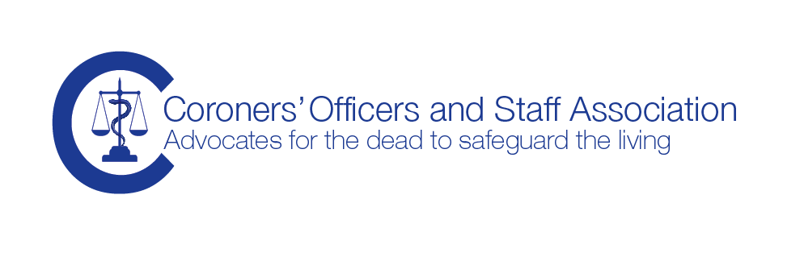

COASA TREASURERS REPORT - AGM 8th October 2015 at Milton Keynes
This year there has been a drive to save as much money as possible to enable the association to develop a new, more functional and more accessible website for members. This is quite an expensive project for the association which is still relatively small and which is reliant for the most part, solely on membership subscriptions. The first phase of the website is now complete and payment for the second phase is due shortly.
That being said the association funds are healthy and currently stand at £6878. We were given a boost last year by the kind sponsorship donation of £1000 from Rowland Brothers. Our funds were further boosted by Essex county council paying the membership subscription fees for all coroner’s officers and staff in its employ. I am pleased to report that Essex are continuing to support their staff this year too.
The Association relies on membership support. We are aiming to put on further study days but as always there is a cost element to them. Sometimes they do run at a small loss, but we feel that the benefit of the training provided outweighs this. This study day is well supported and hopefully it will be cost neutral.
A further project that the COASA will need to consider it’s finances for is the revision of the COASA Guide to Practice and Procedure manual (PPM). There is a significant cost element to this, not only in terms of time for those committed to working on this project, but also in terms of facilitating the work ie travel and accommodation. Where possible we will try to keep the accommodation costs to the minimum by making our own homes available. However there will be travel costs incurred as the PPM group members are widely spread in terms of location.

Chris Hurst, Treasurer
06/10/2015

