ANNUAL REPORT
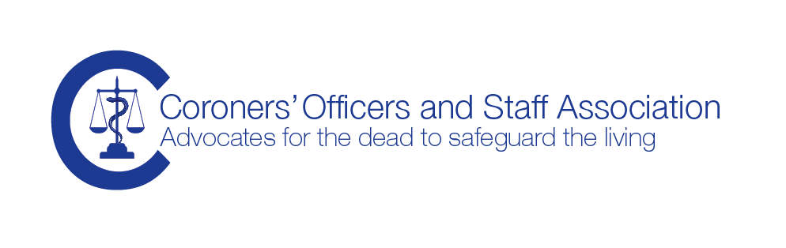

AGM

8th October 2015

Dear Members

It has been another busy year following our last AGM and I have listed some of the projects we have been involved in below. Looking forward, there is much to do: we need to launch the new website and our social media presence which we hope will enable us to stay in contact with you all much more easily; we are very keen to continue with the COASA training and continue to assist the chief coroner with his training; increasingly coroners officers managers are working directly in the coroners’ office rather than being managed more remotely by the organisation and we would like to establish a Managers sub-group. We are continuing our work with many national steering groups and will respond to requests for feedback or to consultation documents, so look out for our call for your comments, they are essential to help us form a response from the Association rather than a few individuals on the council.
We are fast approaching our 20th anniversary (2017). We would like to acknowledge the milestone with the members with an extra special event. We realise that getting time off work is very difficult so the event is likely to be designed around training. We will canvas you for your ideas and interest, but we will start planning soon. What would you like us to do in 2015-2016? - E-mail secretary@coasa.org.uk
The Council of the Association
I would like to record my thanks for the valuable contributions of your Council Members who have continued to work hard on your behalf, despite very busy jobs. I am very pleased that Christine Hurst, one of the founder members has been re-elected to the position of Treasurer, Christine has contributed a very large amount of time to the Association since 1997 and deserves a special acknowledgement, Thank-you Christine. I am very pleased that Jemma Gaule has been elected to the Council, Welcome Jemma. I would also like to express my thanks to Vivien Hughes and Adam Trewerne (both re-elected), Sonia Brooks, Geoff Webb and Sandi Meisner for their support too. I am looking forward to working with the team over the coming year, we have a very strong team working hard to achieve the Aims of the Association on your behalf.
I have been working with the Council since 2000 and have been your Chair for a number of years and I think that this coming year should be my last as your chair. I have thoroughly enjoyed the role but it is time for a fresh face. However, I would like to continue to work with the Council but perhaps in a different capacity. Please accept my thanks in electing me to the position.
If you are interested in working with the council, either as an elected or co-opted member or if you have a particular interest, skill or experience you would like to share, then please do get in touch with a council member or contact us at secretary@coasa.org.uk
Membership
Our membership continues to grow steadily and we encourage you to solicit new members from amongst your colleagues, coroners’ officers and coroners’ staff. We do have significant interest in our Association from persons that work alongside the coroner service and have an increasing number of affiliate members. The larger our membership, the stronger our voice will be. At only £60 per year, many employers or coroners are paying the membership subscription for the staff as the benefits include a complimentary copy of the coroner’s officers handbook, highly subsidised training and a massive information resource via the website (look out for the new website, coming soon). As we have linked the cost for training with membership applications it is now even easier to join, so watch out for the special promotion when we advertise our next training day.
You can help us, if you have colleagues in your office that are not members, then please do let us know, send us their name, work e-mail and postal address so that we can add them to our mailing list. Send the information to membership@coasa.org.uk

Training
Since its formation in 1997 COASA has provided a range of excellent training events, either as stand alone study days or working in partnership with a university or other organisations and now COASA are members of the chief coroners training group working with the Judicial College. The Association is extremely fortunate to have a training group with extensive experience working in the coroner service combined with many years experience as educators and trainers. COASA argued strongly that training for coroners’ officers and staff should be mandatory and we are very pleased that the chief coroner has stated the same and it is now a statutory obligation.
Debbie and Christine are members of the chief coroners Coroner’s Officer Training Group, the course director is Derek Winter, senior coroner Sunderland who is an affiliate member of the Association. Derek has been a long standing supporter of COASAs call for training for coroners officers. Chris and Debbie worked hard to assist with the planning and creation of the 2015 coroner’s officer continuation training, we hope that you enjoyed it. We are working with the chief coroner and Derek to plan for the 2016 programme. Make sure that you book yourself on the course.
If you have a suggestion for future training topics please tell us training@coasa.org.uk
Bereaved Through Substance Use: guidelines for practitioners
A research study by The University of Sterling and The University of Bath found that those left bereaved after a drug or alcohol related death often receive poor, unkind or stigmatising responses which can exacerbate their grief. A project team went onto hold focus groups, mainly practitioners but also some people bereaved through drug or substance use to develop guidance for practitioners coming into contact with bereaved people. Christine Hurst represented COASA on the working group to produce the handbook. Find the guidance at http://www.bath.ac.uk/cdas/documents/bereaved-through-substance-use.pdf
National Bereavement Alliance
The NBA is an alliance of organisations or individual professionals working with people along the end of life pathway. It includes palliative nurses, bereavement professionals, including family support groups, independent counsellors, funeral directors, anatomical pathology technologists and coroner’s officers. The work has been supported by the Dying Matters coalition and the Dept of Health. The Alliance was initiated jointly by the Coroners Officers and Staff Association, the Bereavement Services Association and the Association of Anatomical Pathology Technology. This is definitely something COASA may feel proud to have been involved in.
Suicide Bereavement Alliance
COASA has recently been invited to participate in a new initiative bringing together all those professionals and support groups working with people bereaved through suicide. The Alliance is developing a framework and national guidance. We will of course update you as the work progresses.
HSE Safe Working and Prevention of Infection in the Workplace
The document is in the process of being updated and COASA is on the steering group. We will let you know when the revised document has been published. Sandi, Tony and Debbie have been working on this.
COASA website and Social Media presence
COASA is getting a fresh look, we have a new logo and Website under development. Some of you may have seen the Facebook and Twitter announcements. We will also be developing a Linked-In presence. We are cautious about the use of Social Media, as we cannot do or say anything that could bring the coroner service into disrepute (we will of course be subject to the Judiciary Code of Conduct because we perform duties on behalf of judicial office holders). We see the Social Media as a way to stay in touch with you, for example alerting you to issues or information, which you will be then be able to access in a secure area on the website.
Department of Health – death certification reform
The expected consultation on the introduction of the Medical Examiner system has still not happened. There has been some recent activity from the Dept Health death certification steering group, but we have not been advised of the current position. We will of course update you as soon as we have news.

Department of Health Suicide Prevention Steering Group

COASA has been involved with the steering group for many years. The group is currently revising the document ‘Help is at Hand’ a resource for people bereaved through suicide

Coroner Court Support Service Executive Committee

Sonia represents the Association on the national committee

The Death Investigation Stakeholder Group

The work on these groups was progressing well, but work stalled, which was highly disappointing. Debbie has recently contacted all the stakeholders and we are planning to meet on 19 November to re-start the work and the National Police Chiefs Council NPCC (formerly ACPO) representative will be there. The group is looking at the work of the coroners’ office, the job description for coroner’s officers and coroner’s staff and caseload etc. We know that the job descriptions and staffing – caseload numbers varies widely across the country and this is a piece of work that the Chief Coroner is working on and is very keen to issue guidance on.

All Party Parliamentary Group – Funerals

COASA made a submission following a call for reasons for delays and Debbie was subsequently invited to attend the House of Commons to give evidence. The report has been delayed as the chair of the group lost her seat in the general election. We will circulate the report as soon as it is published.

Mass Fatality planning

The council has several members who have been involved in mass fatality planning as part of a national or regional steering group and members who have responded to mass fatality incidents. We know that it is a topic of great interest to all of you and we hope to bring some work together and establish some training for coroner’s officers. Watch the website for information in 2016

COASA Handbook: the coroners office, a guide to practice and procedure

We do not have many copies left and it is time to start thinking about an update. This is a significant amount of work to undertake, do you want to see a new edition? do you have any suggestions for the next edition? Let us know what you think….. training@coasa.org.uk

Rowlands Brothers International

Special thanks to Rowland Bros for their sponsorship in 2014-2015, particularly for the Adult Safeguarding study day

A Note to all Members from the Chair

I would like to offer my sincere thanks to each of you, the membership, for your continued support. I know that many of you are under severe pressure, the past 18 months has seen many changes in the work and increased case numbers particularly as a result of DoLS, and I know that for many of you the workload has increased at a time when staffing levels may be falling or frozen.

Much of the work of the Association is not ‘visible’, but please be reassured that we continue to speak on your behalf at every opportunity. I will of course continue to work hard on your behalf along with my council colleagues.

If you would like to contact me, I am always glad to hear from members, whether it is information you want to share, or something you think I may be able to assist you with, please do get in touch.

Thank-you for your valuable support.

Debbie Large

Chair, Coroners’ Officers and Staff Association

8th October 2015
01634 799182 | chair@coasa.org.uk | 115 Charles Drive, Cuxton, Rochester, ME2 1DU
COASA general correspondence to: secretary@coasa.org.uk | PO Box 3781, Chester, CH1 9YJ

